User manual

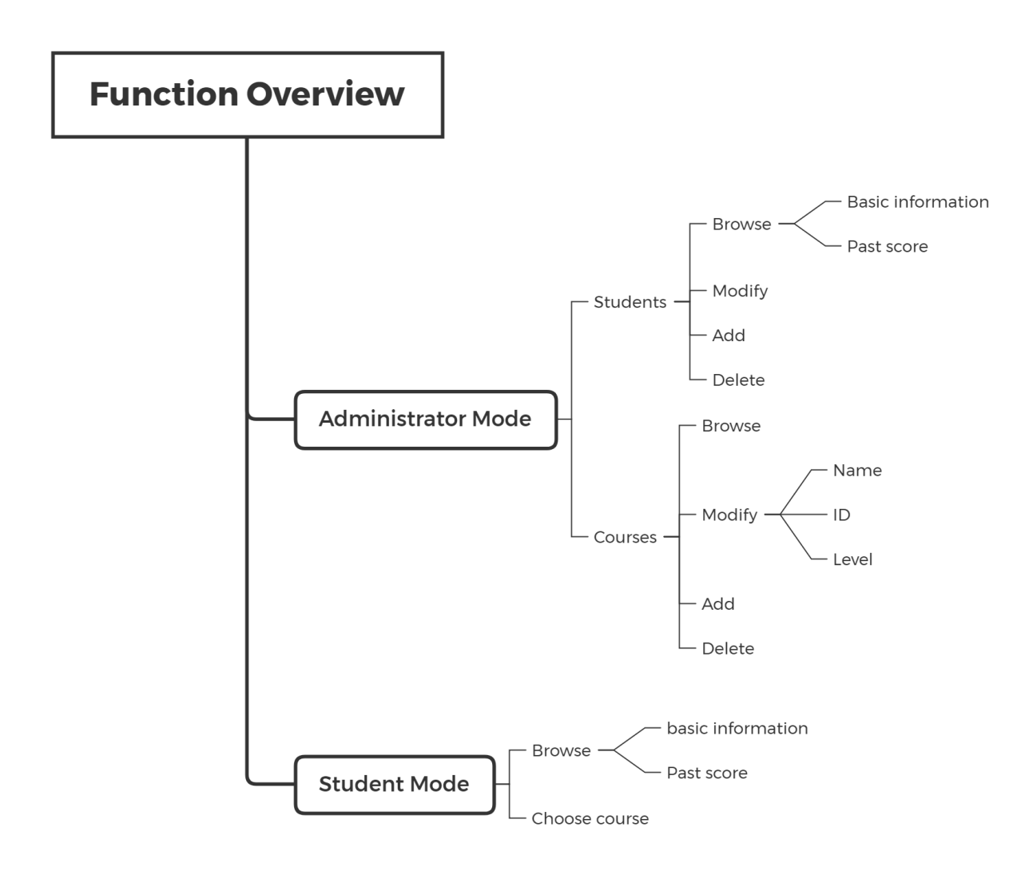

1. Administrator Mode
   1. Administrator Log in

Step 1: Run the system and the login interface will be automatically displayed;

Step 2: When the system asks your identity, input “1” to log in as an administrator;

Step 3: Input your id and password as the corresponding position

(example account: id: 0000, password: admin);

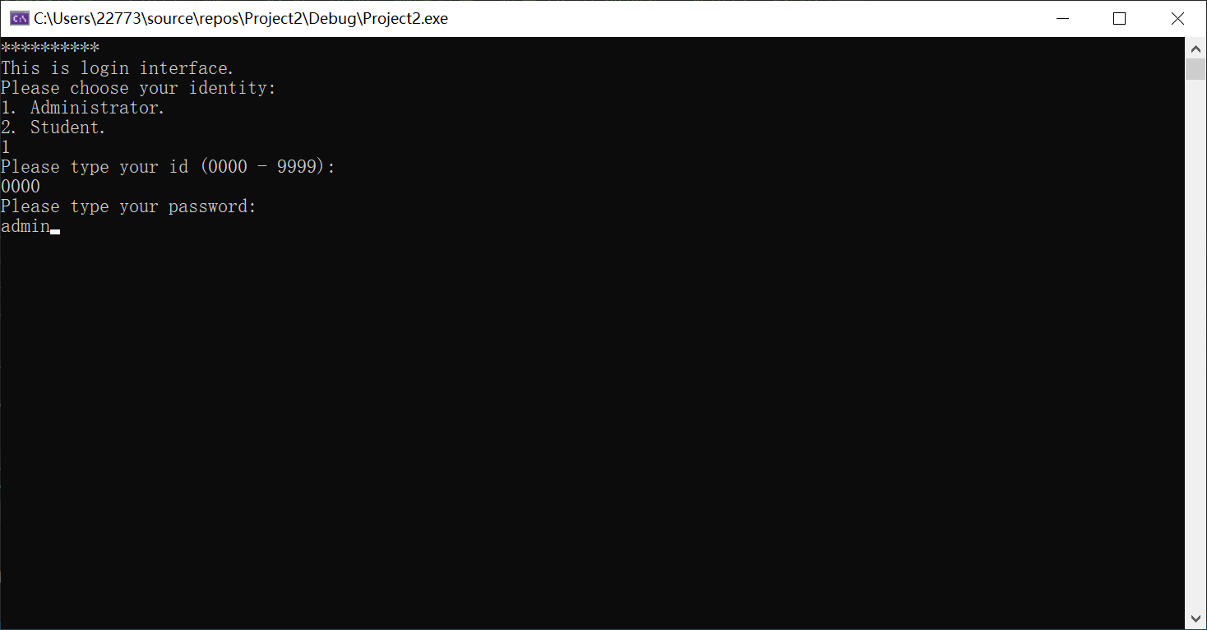

Step 4: When the system shows “Welcome, administrator!” and operation object options, it means that you have logged in successfully.

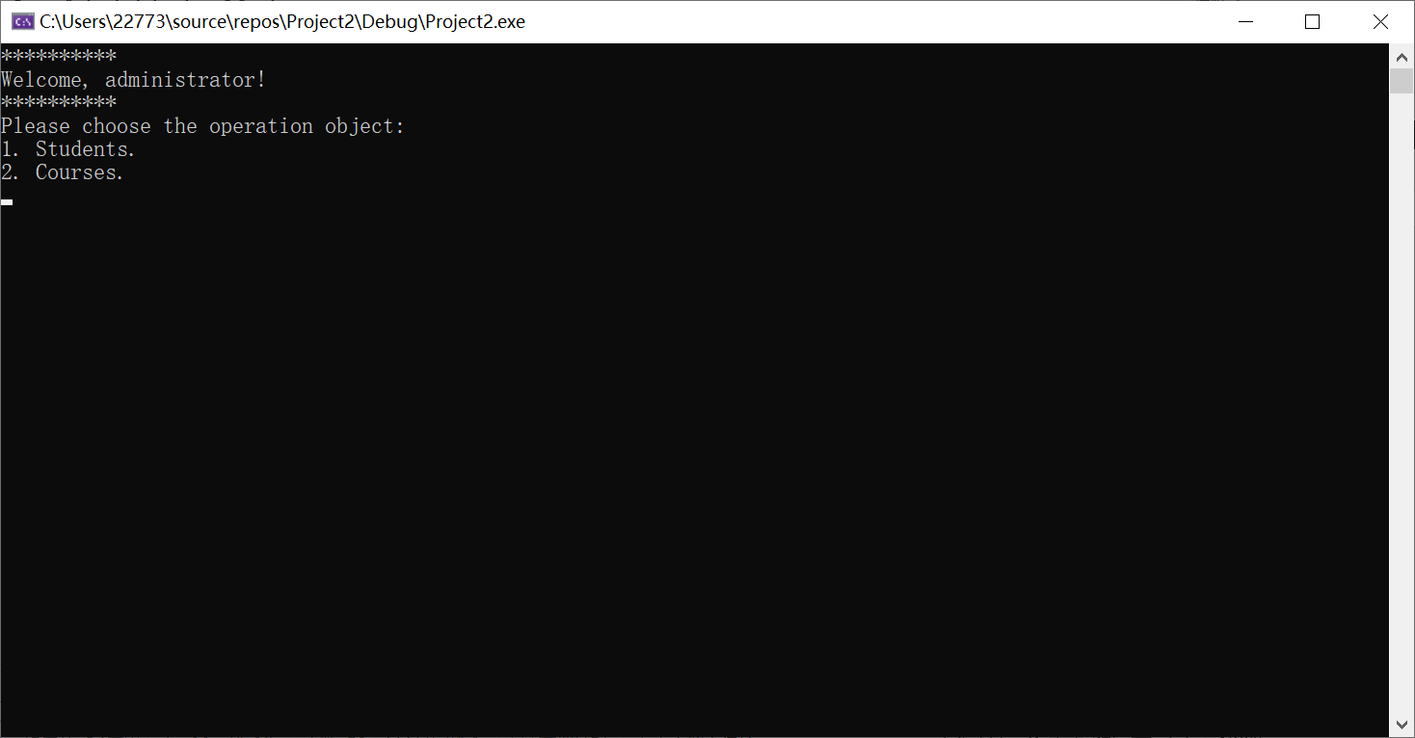

* 1. Administrator Browse Students Information

Step 1: Log in as the administrator identity and choose the “students” as the operation object;

Step 2: Type 1 to choose “Browse”;

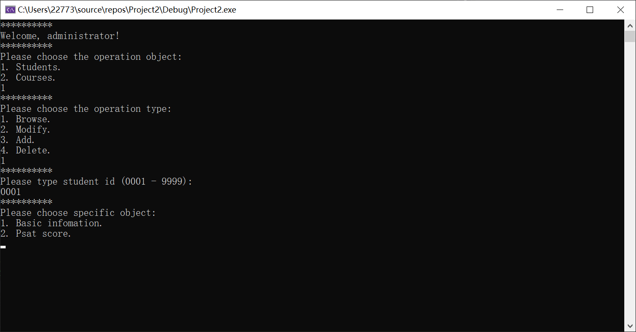

Step 3: Input the ID of the student you want to browse and then you can browse the information of student basic information and past score;



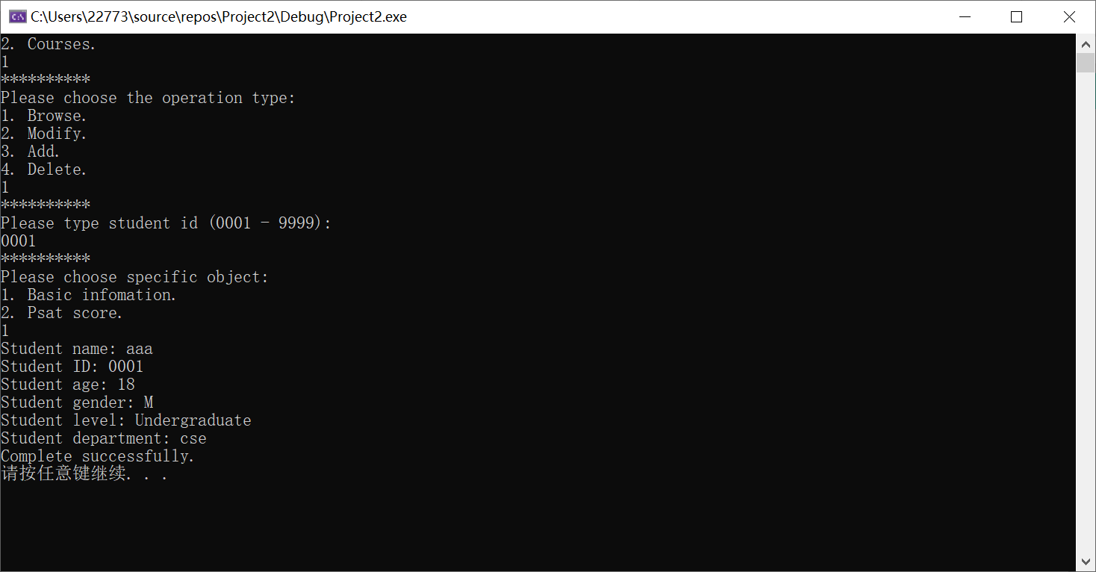

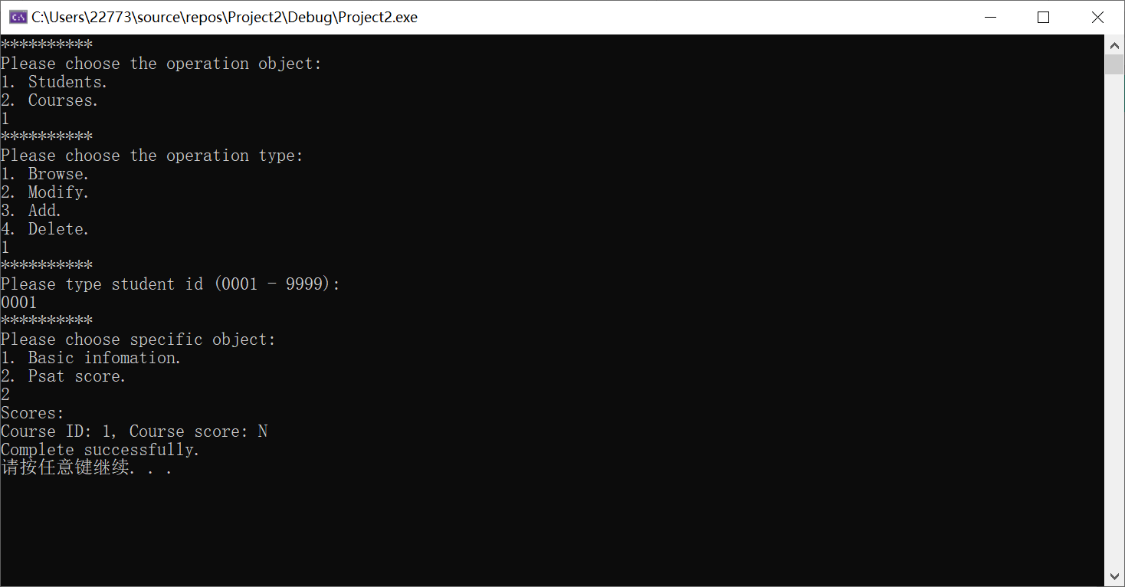

* 1. Administrator Modify Students Information

Step 1: Log in as the administrator identity and choose the “students” as the operation object;

Step 2: Type 2 to choose “Modify”;

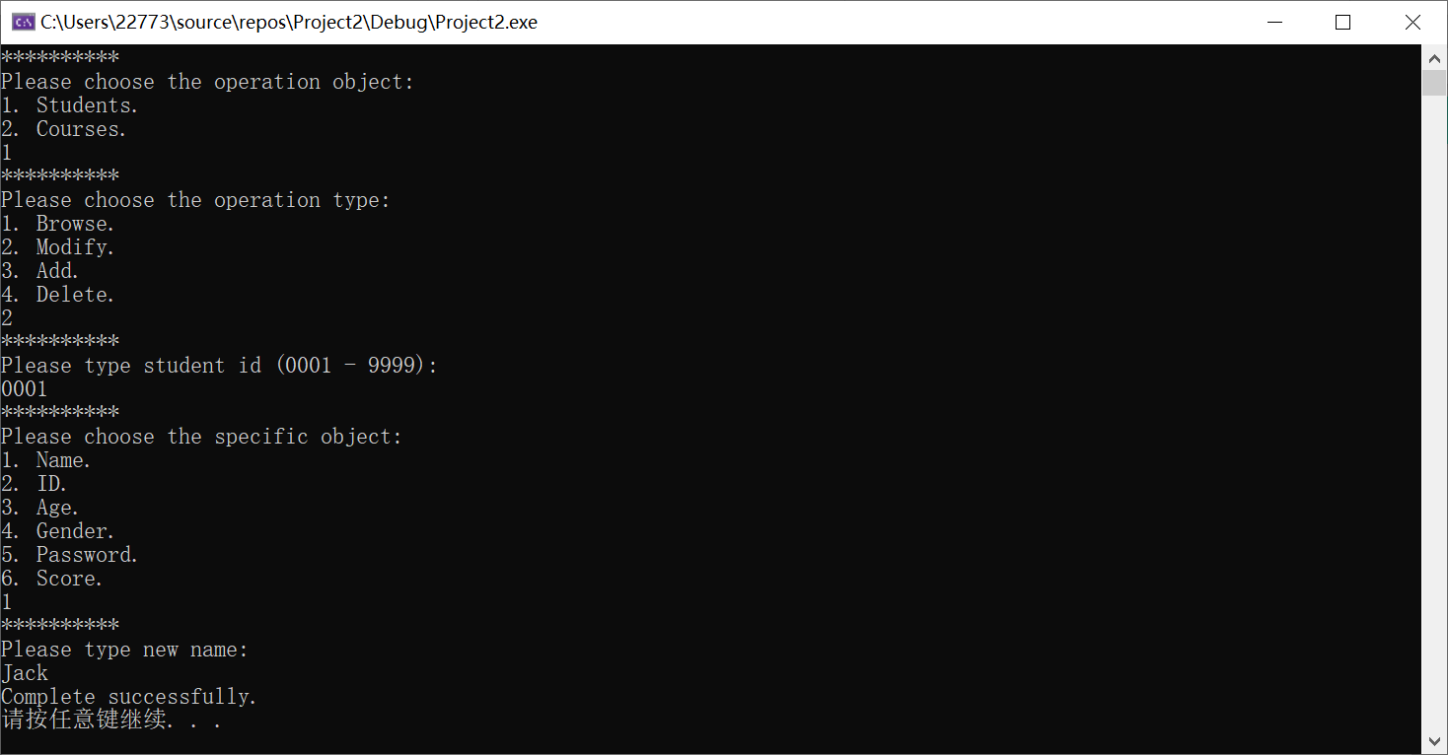

Step 3: Input the student’s ID and choose the specific part of information; 

Step 4: You can find that the name of student 0001 has been changed into Jack;

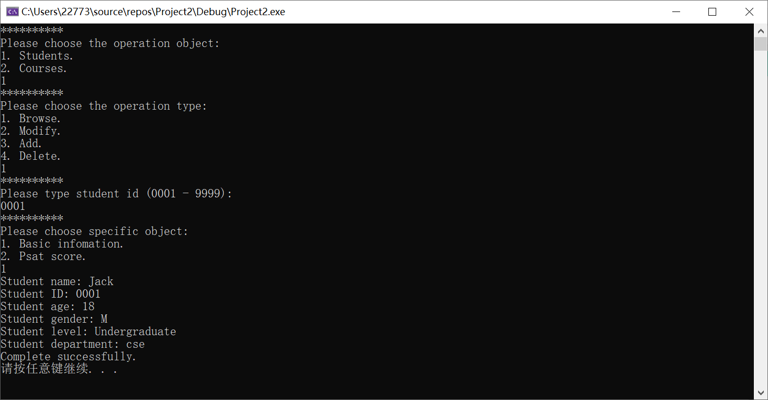

* 1. Administrator Add a New Student

Step 1: Log in as the administrator identity and choose the “students” as the operation object;

Step 2: Type 3 to choose “Add”;

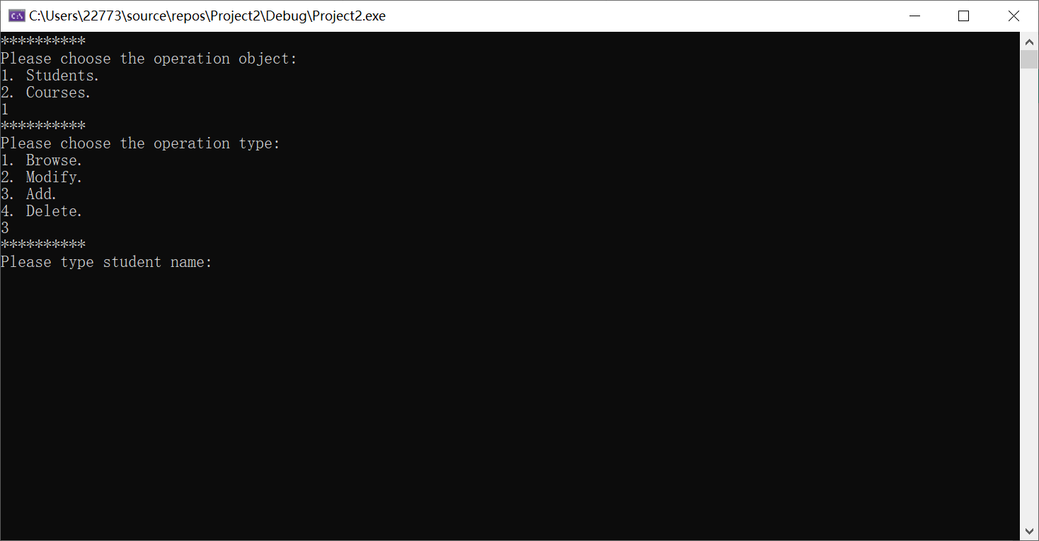

Step 3: Input the information including name, age, gender, level, major and department;

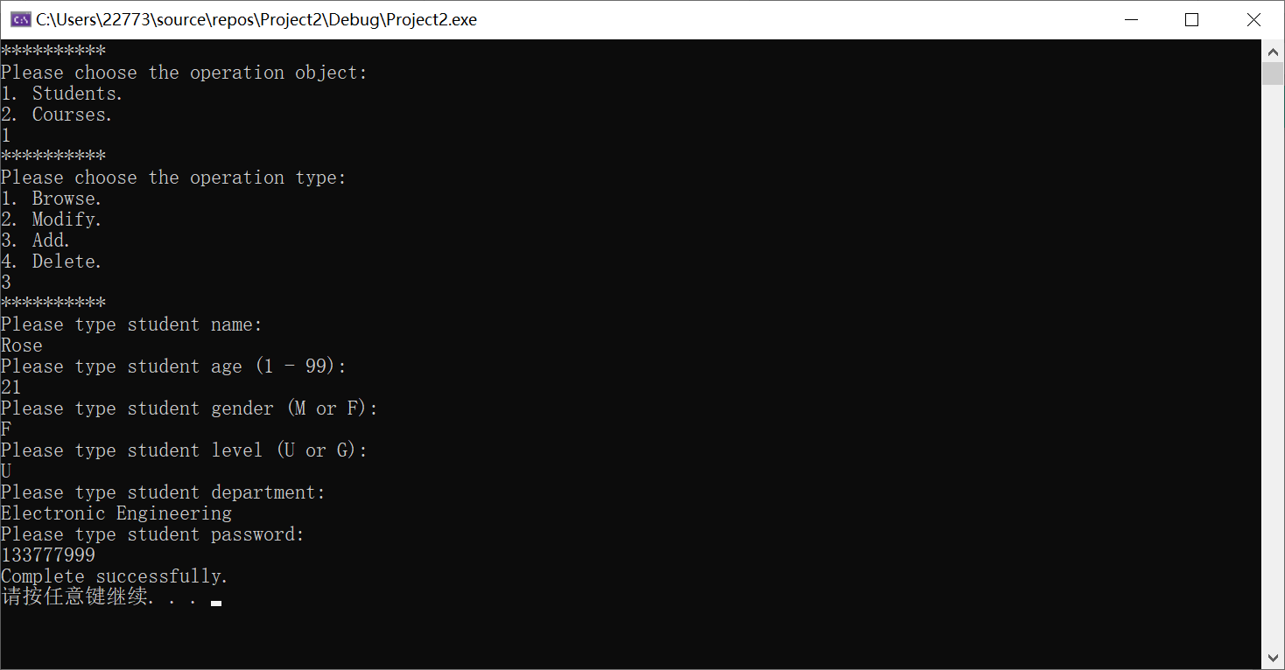

Step 4: You will find that the student 0003, Rose has been added into system;

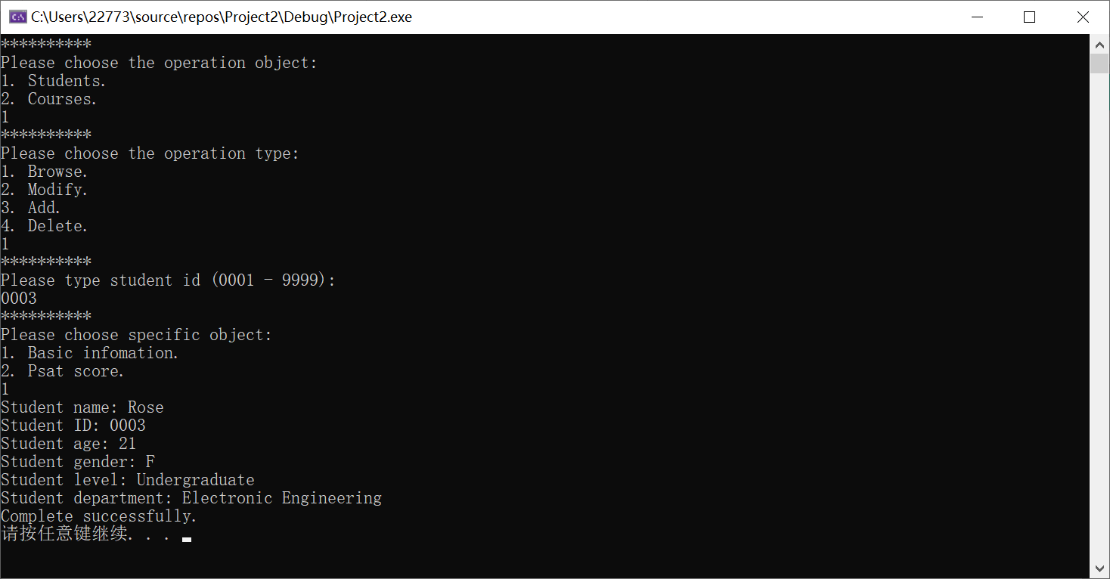

Step 5: Rose can log in as the student identity;

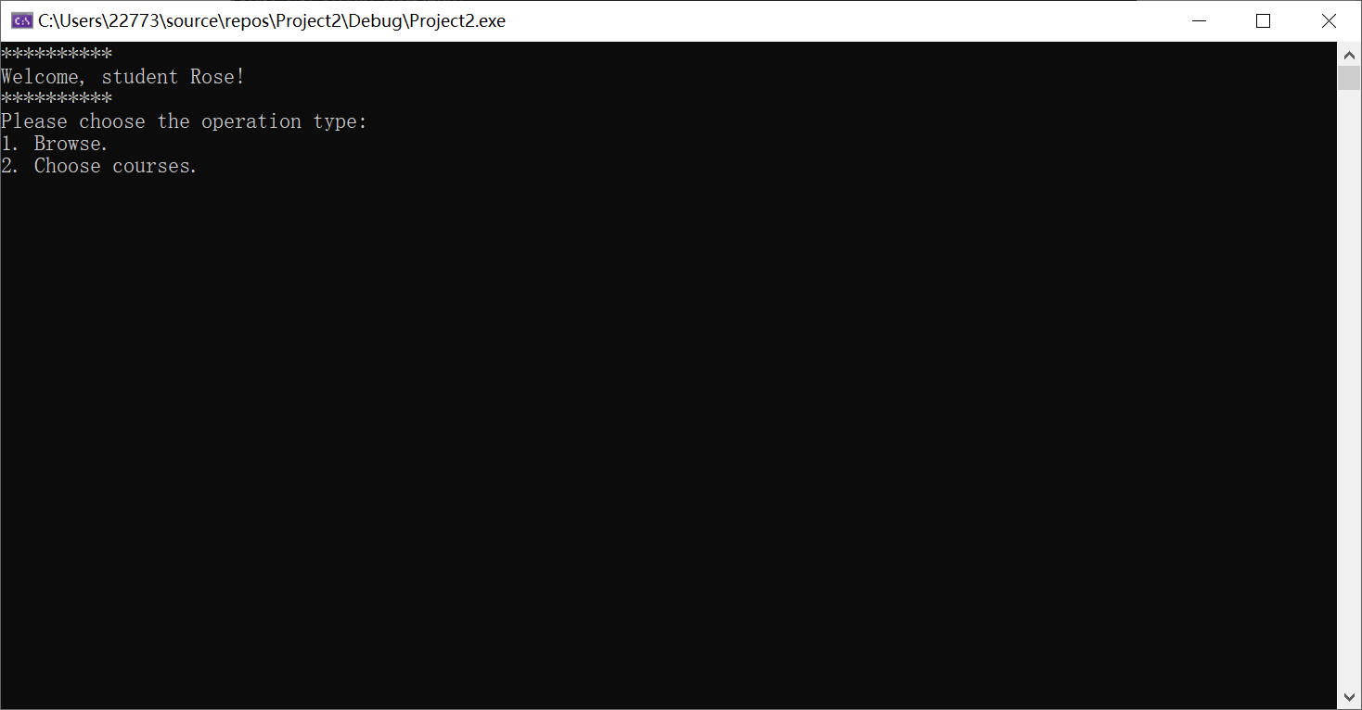

* 1. Administrator Delete a Student from the System

Step 1: Log in as the administrator identity and choose the “students” as the operation object;

Step 2: Type 4 to choose “Delete”;

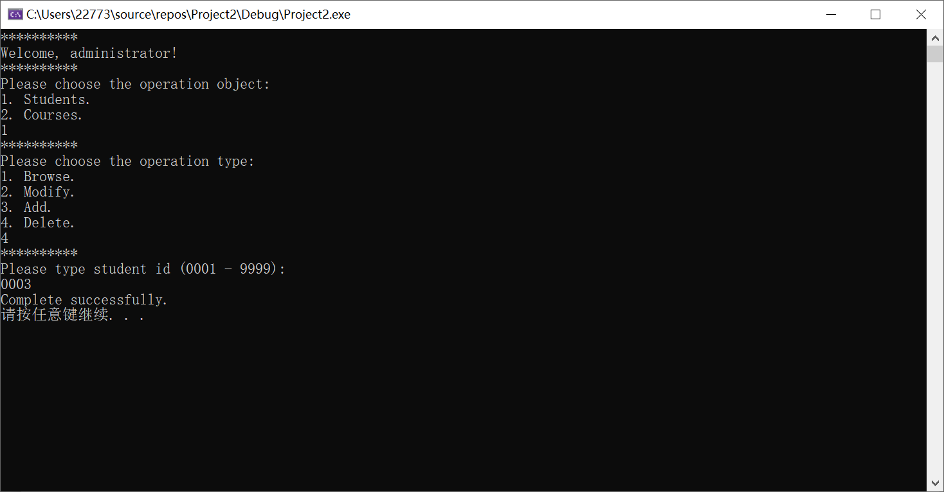

Step3: Student Rose has been deleted from the system;

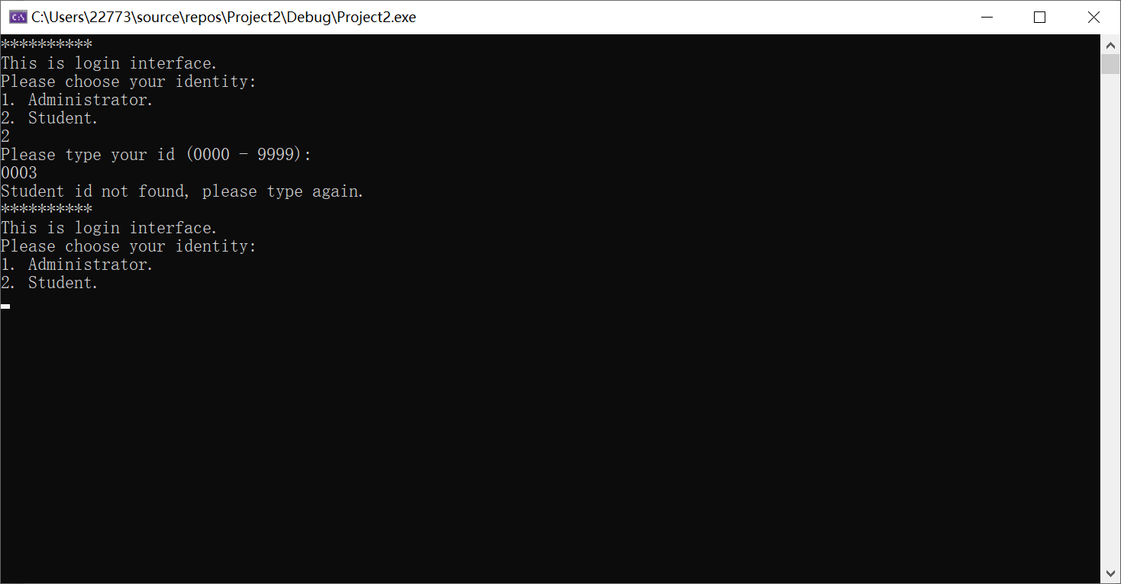

* 1. Administrator Browse the Course Information from the System

Step 1: Log in as the administrator identity and choose the “courses” as the operation object;

Step 2: Type 1 to choose “Browse”;

Step 3: Choose a specific course by inputting the course ID;

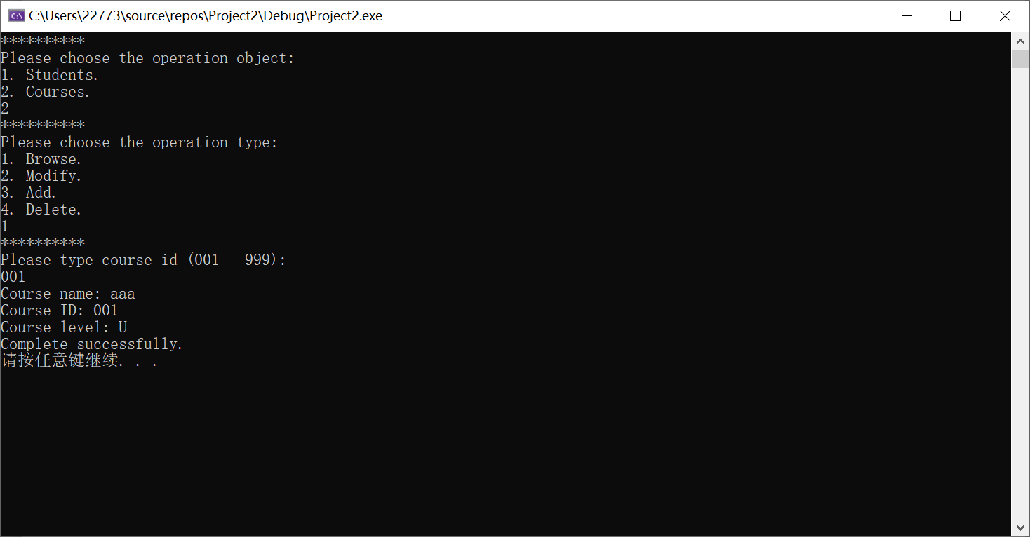

Step 4: The information of course 001 including name, ID, and level has been displayed;

* 1. Administrator Modify the Course Information from the System

Step 1: Log in as the administrator identity and choose the “courses” as the operation object;

Step 2: Type 2 to choose “Modify”;

Step 3: Choose a specific course and object to change;

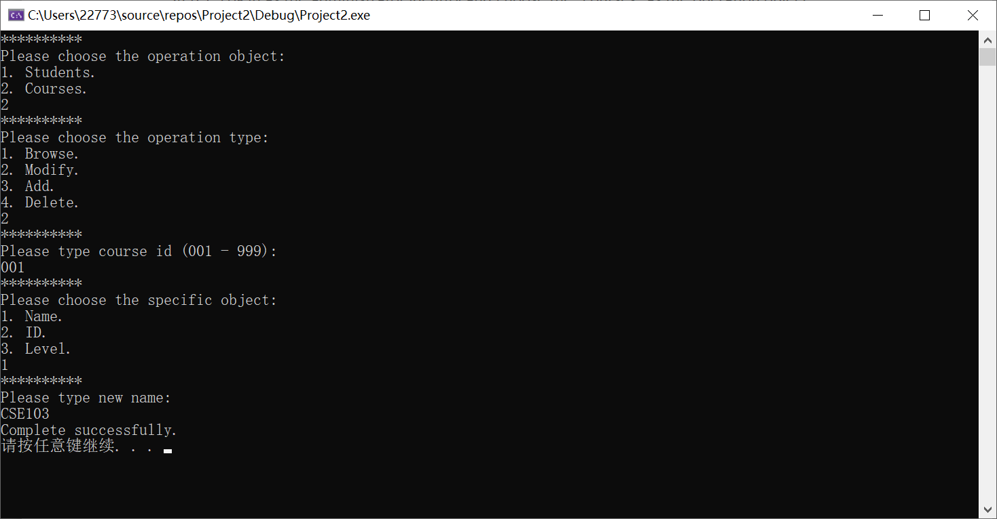

Step 4: You will find that the name of the course 001 has been changed into “CSE103”;

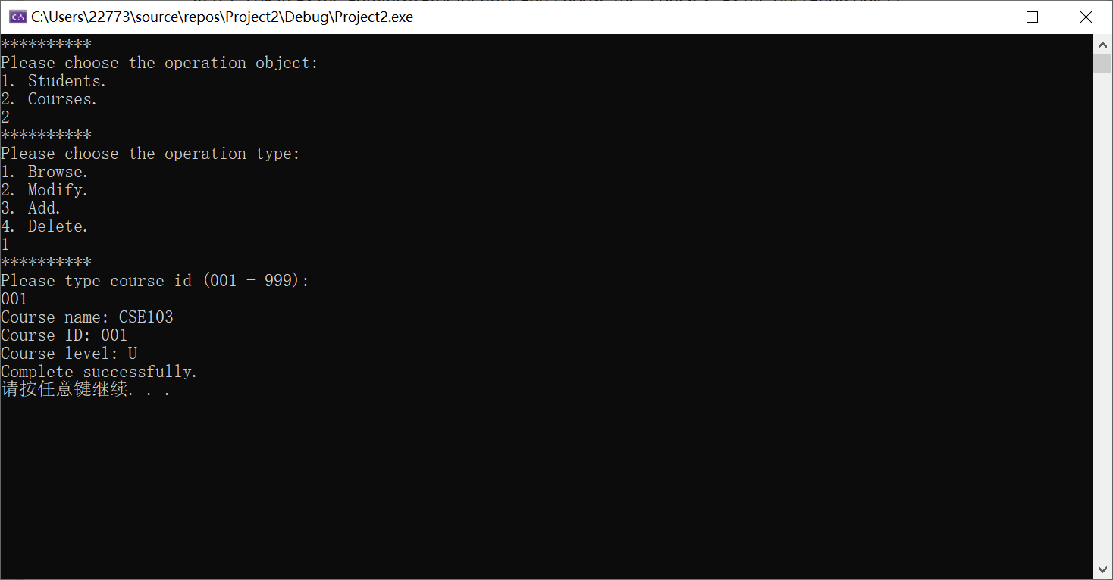

* 1. Administrator Add a Course into the System

Step 1: Log in as the administrator identity and choose the “courses” as the operation object;

Step 2: Type 3 to choose “Add”;

Step 3: Input the information of the new course including name, ID, and level;

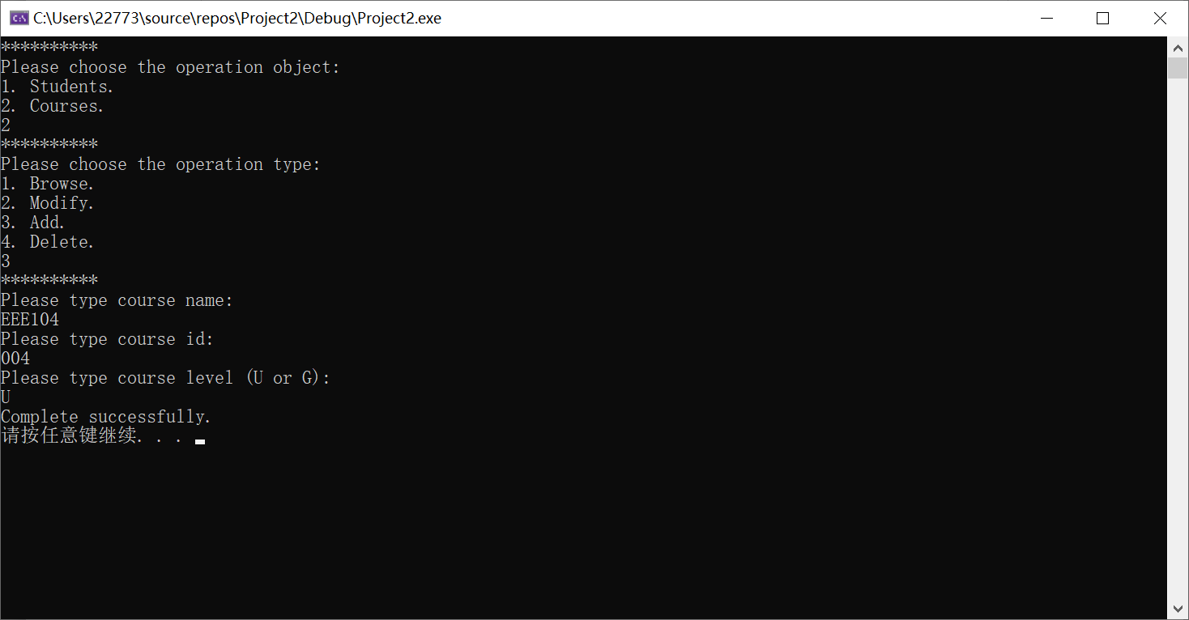

Step 4: You can find that course 004, EEE104 has been added into the system;

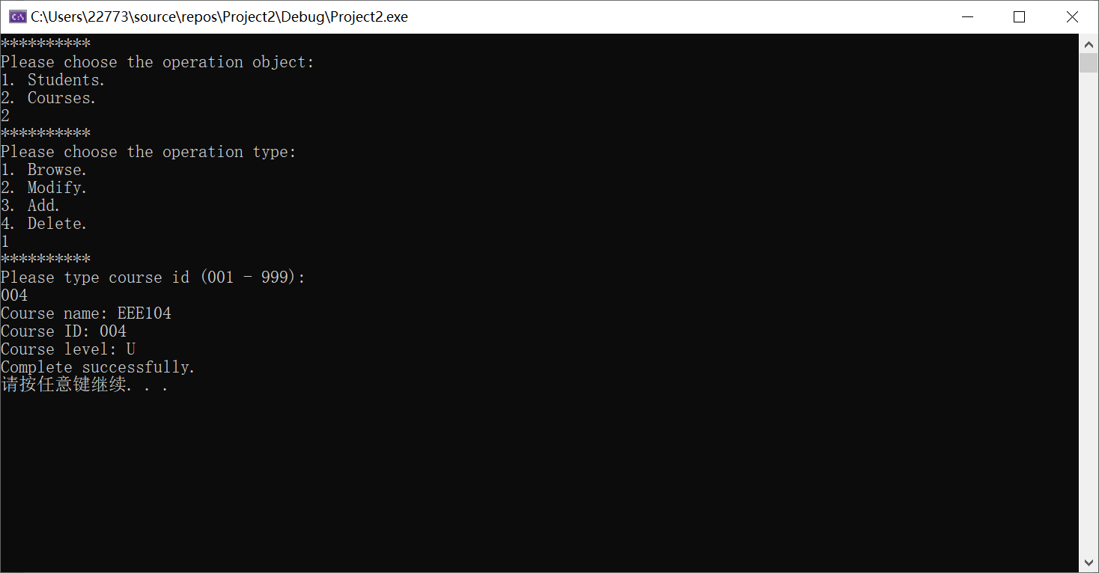

* 1. Administrator Delete a Course from the System

Step 1: Log in as the administrator identity and choose the “courses” as the operation object;

Step 2: Type 4 to choose “Delete”;

Step 3: Input the ID of the course you want to delete;

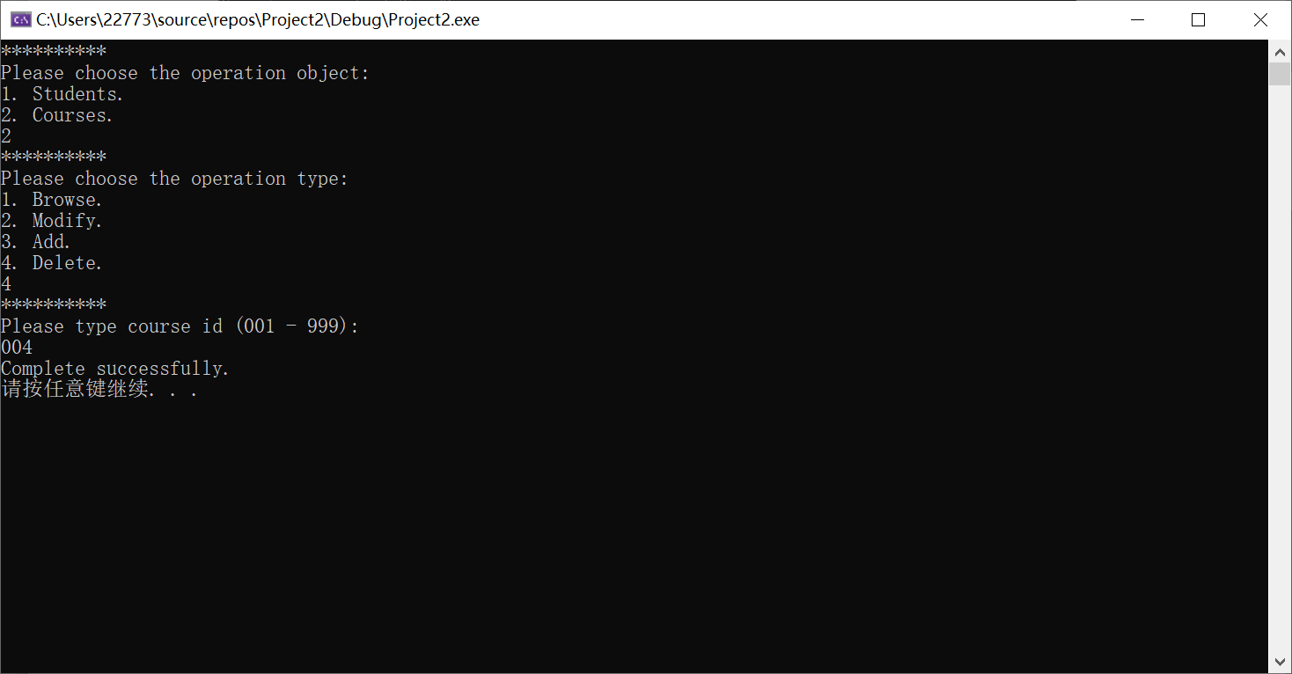

Step 4: Course 004 has been deleted;

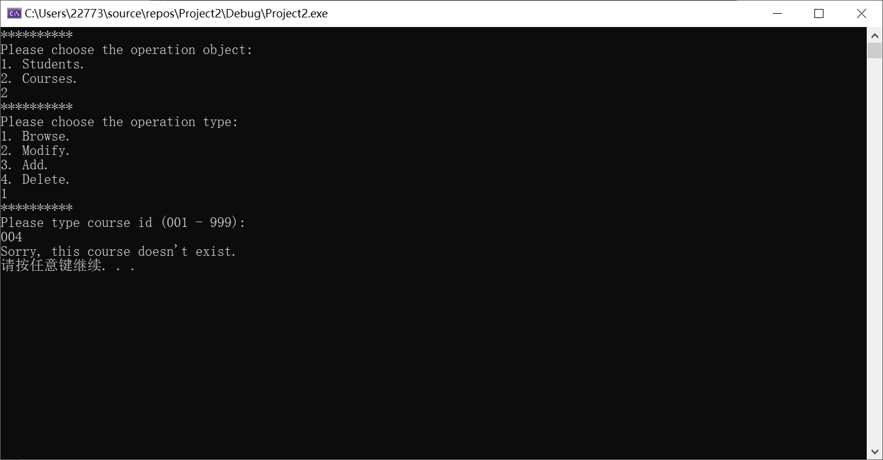

1. Student Mode
   1. Student Log in

Step 1: Run the system and the login interface will be automatically displayed;

Step 2: When the system asks your identity, input “2” to log in as a student;

Step 3: Input your id and password as the corresponding position

(example account: id: 0001, password: xxx);

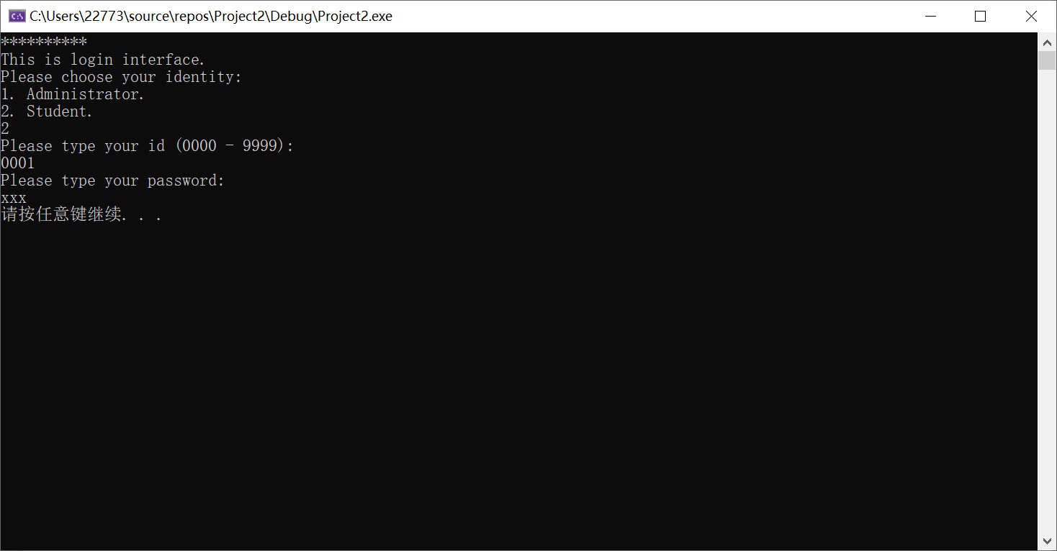

Step 4: When the system shows “Welcome, student!” and operation object options, it means that you have logged in successfully.

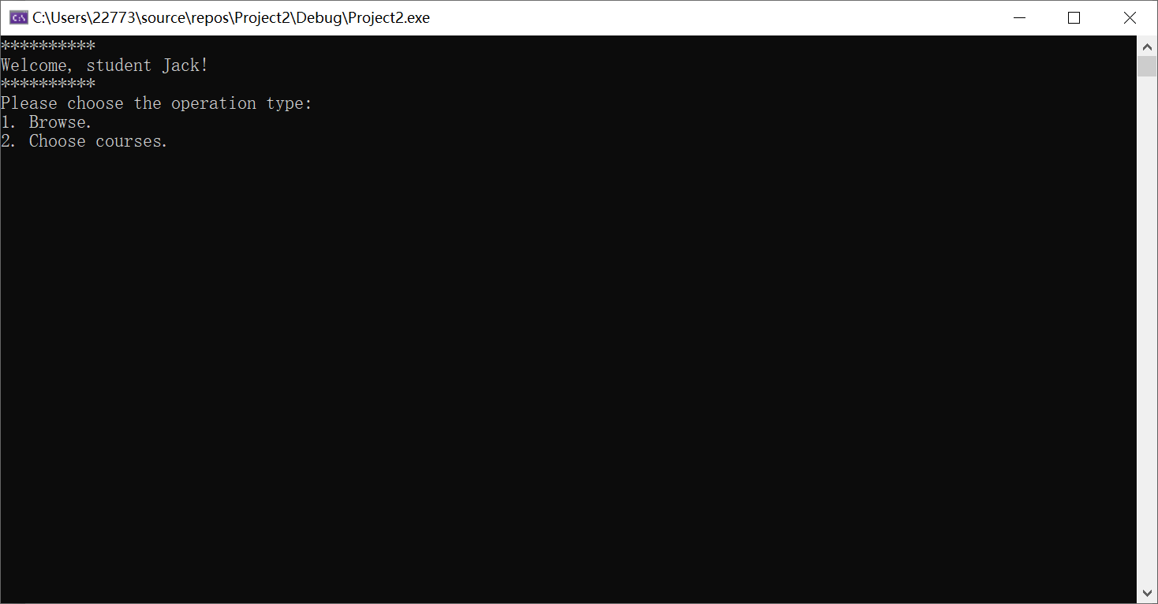

2.2 Student Browse the Basic Information or Past score

Step 1: Log in as the student identity and choose the “browse” as the operation object;

Step 2: Type 1 to browse the basic information and type 2 to browse the past score;

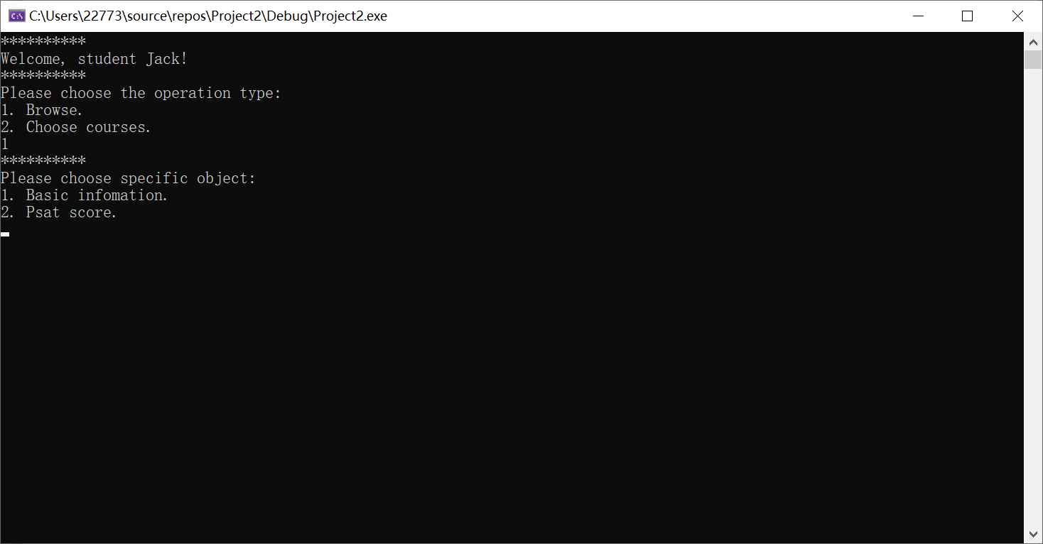

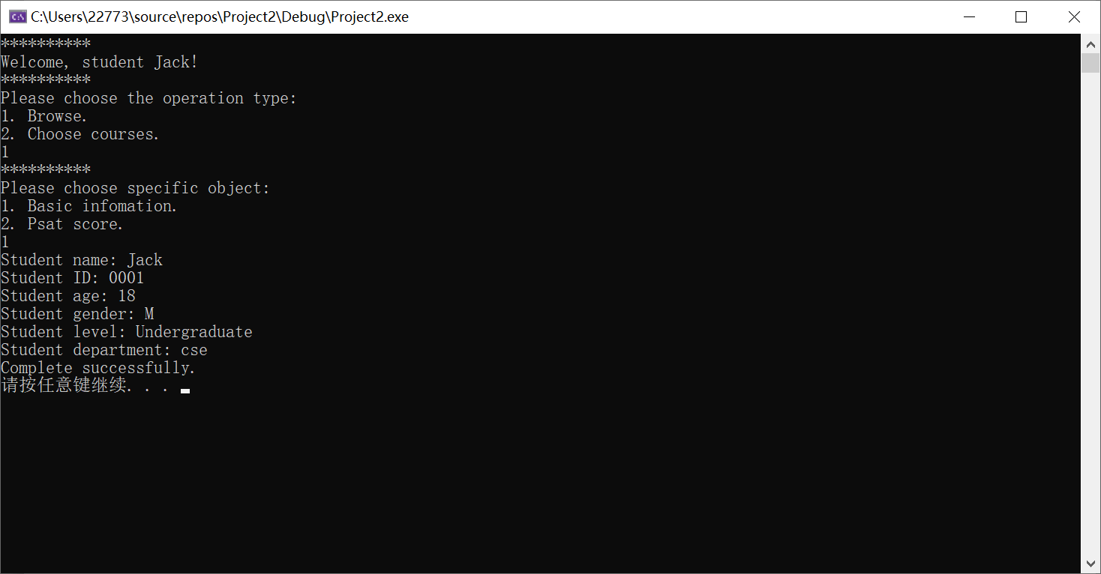

2.3 Student Choose a New Course

Step 1: Log in as the student identity and choose the “browse” as the operation object;

Step 2: Choose the available course and you will find that the new course 7 has been added to your course list;

